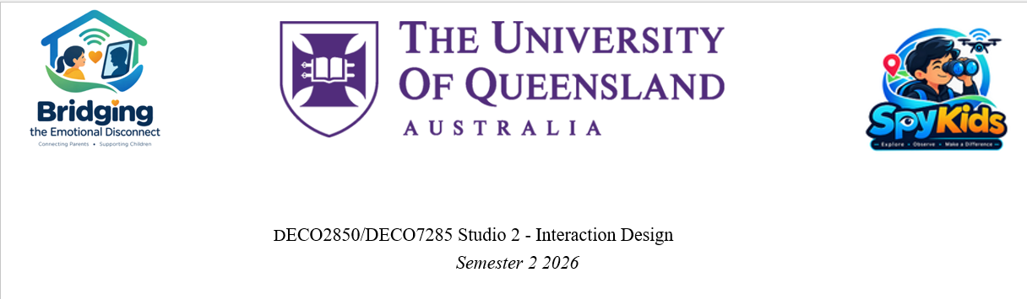

Master Project Scope & Combine Qualitative Data Analysis and Findings
Document No: SK-P1-002.4
Comprehensive Synthesis Matrix: Preserving All Original Empirical Data, Literature Findings, & Interactive Digital Parental Embodiment Ideas.

1. Master Project Scope Definition
- Project Title: Bridging the Emotional Disconnect: Designing an Interactive Digital Parental Presence for Left-Behind Children (Aged 6–12) in China
- Target Demographic: Left-behind primary school children aged 6–12 in China, geographically separated migrant parents, and their local primary caretakers/support network.
- Problem Statement: Physical separation degrades emotional closeness over time. Standard synchronous calls create a 'visibility gap' characterized by administrative check-ins, lack of common topics, and emotional detachment.
- Primary Objective: Design a digital platform that embodies parental characteristics (voice, facial features, empathetic greetings) to allow left-behind children to interact digitally with their parents asynchronously, maintaining daily connection and emotional intimacy.
- In-Scope Boundaries: Children aged 6–12; migrant parents; caretakers and support network (upcoming interview participants); continuous digital parental embodiment; non-verbal/voice presence; interactive micro-touchpoints; rural/urban China migration context.
- Out-of-Scope Boundaries: Adolescents aged 13+ and 5-; generic video/chat apps lacking interaction mechanics; fully autonomous AI replacing real parental input; macroeconomic policy reform.

2. Participant Group Coverage Audit & Identification of Gaps
Stakeholder Group | Represented In Raw Data? | Specific Participant / Source | Status & Action Required
Left-Behind Children (Aged 6–12) | Indirect / Retrospective | Participants A, B, C, D (Retrospective adult accounts); Videos 1, 2, 3 (Observed kids) | GAP IDENTIFIED: Primary data relies on retrospective memories. Conduct interviews/co-design sessions directly with children aged 6–12 to test digital parental embodiment concepts.
Migrant Parents (Absent/Working) | Missing (0 Direct Interviews) | Not interviewed directly; only mentioned via children's & teacher's reflections | CRITICAL GAP: Zero direct parent interviews. Conduct interviews with active migrant parents to collect voice/visual asset parameters and work schedule constraints.
Primary Caregivers (Grandparents) | In-Scope (Pending Fieldwork) | Reflected via Participants A, B, C, D and Volunteer Teacher (Student Li) | UPCOMING PARTICIPANTS: Defined in updated scope. Conduct direct interviews with rural grandparents to evaluate digital platform ease-of-use and setup burden.
Teachers & Educational Support Network | Directly Interviewed & In-Scope | Student Li (Volunteer Rural Teacher); Middle School Teacher referenced in Interview A & C | PARTIALLY COVERED & IN-SCOPE: Volunteer teacher perspective captured. Conduct planned interviews with support network members regarding child reception of digital avatars.
Peers & Local Support Network | Indirectly Referenced & In-Scope | Participants A, B, C, D (Friends/Cousins mentioned as key emotional outlet); Community neighbors | IN-SCOPE PARTICIPANTS: Defined as key support network in updated scope. Conduct observations during prototype testing to assess peer interaction and potential stigma.
3. Exhaustive Empirical Synthesis Matrix: Comprehensive Findings & Digital Parental Embodiment
Literature Findings | Primary Interview Data & Stakeholder Role | Digital Ethnography Data | Synthesized Key Theme | Design Principle | Main Ideas (Original + Digital Parental Platform)
Logistical Communication Skew:  Over 70% of long-distance communication defaults to administrative check-ins (Madianou & Miller, 2012).  Intermittent Connectivity:  Asynchronous tools bridge time-zone and work schedule conflicts (Xu et al., 2020). | [Volunteer Teacher - Student Li]: Calls default to 'Have you eaten?' / 'Yes' because they 'didn't really know what to say'.  [Child Perspective - Part. A]: Calls covered grades/behavior; felt like interrogation.  [Child Perspective - Part. B]: Infrequent calls led to total silence.  *GAP: Need Migrant Parent view.* | Transactional Contact:  Video 3 shows technology enables basic contact, but scheduled calls fail to generate emotional connection (Video 3).  Surface-Level Sharing:  Video 1 highlights children sharing surface activities rather than deep feelings during brief calls. | The Shared Context & Conversation Void:  Synchronous calls fail because physical separation removes shared daily context, forcing calls into rigid, transactional interrogations and awkward silence. | Asynchronous Personalized Micro-Interactions:  Replace scheduled verbal reporting with asynchronous daily interactions driven by parental visual, vocal, and micro-prompt inputs. | 1. Asynchronous Daily Storytelling Kit: Shared digital journal for daily micro-updates.  2. Parental Micro-Greeting Hub: Platform where parents upload daily micro-greetings, short videos, and vocal reactions, giving children interactive, on-demand updates on how their parents are doing.
Psychological Risk & Intimacy Erosion:  Separation causes >35% increased risk of anxiety/depression (Fellmeth et al., 2018) and emotional detachment (Hong & Fuller, 2019).  Visual Presence Need:  Non-verbal presence cues foster emotional closeness across distance (Zhao, 2019). | [Child Perspective - Part. A, C]: Stopped saying 'I miss you', hid emotional needs, felt resentment during sudden parental lectures.  [Child Perspective - Part. D]: Relied on sibling bond for daily emotional comfort.  [Friends Context - Part. C, D]: Turned to peers/friends for primary emotional outlet. | Unmet Emotional Support:  Video 2 demonstrates physical care by grandparents does not replace parental emotional connection, leaving internal loneliness.  Visual Empathy Gap:  Video 3 shows children seeking physical cues of affection that phone calls cannot transmit. | Emotional Masking vs. Ambient Familiarity:  Direct verbal interrogation causes emotional withdrawal; children crave continuous, empathetic parental presence tailored to their parents' visual/vocal traits. | Embodied Parental Familiarity & Empathy:  Integrate distinct physical characteristics (facial likeness, voice tone, familiar phrasing, physique) into the digital interface to evoke real intimacy and empathy. | 1. Tangible Presence Object: Connected physical lamp/plush transmitting ambient warmth.  2. Interactive Digital Parent Avatar: A personalized digital persona modeling the parent's facial features, tone of voice, and physical expressions that empathizes with the child's mood ('How are you doing today?') and delivers parental reassurance.
Caregiver Capability Gap:  Grandparents provide physical care but struggle with emotional, developmental, and educational guidance (Hong & Fuller, 2019).  Digital Divide:  Elderly rural caregivers face significant digital literacy barriers (Sun & Zhang, 2021). | [Caregiver Gap - Part. A, B, C]: Grandparents provided food/warmth but could not advise on school or emotions.  [Teacher - Student Li]: Boy lived with cognitive-impaired grandfather; extreme caregiver strain.  *UPCOMING: Fieldwork with caretakers.* | Caregiver Limitations:  Video 2 highlights that relative support differs significantly from parental guidance.  Device Friction:  Video 1 shows elderly grandparents struggling to configure video apps or maintain device connectivity. | Caregiver Burden & Direct Parent Connection:  Grandparents lack digital literacy to setup complex tools; children need direct, friction-free interaction channels to their absent parents without burdening caretakers. | Caregiver-Light Autonomous Operation:  Design simple, child-driven touchpoints requiring zero setup, maintenance, or technical intervention from elderly caretakers. | 1. Caregiver-Assist Setup Wizard: Simplified plug-and-play UI for elderly adults.  2. Frictionless Child Touchpoint: A simplified, child-friendly interface where kids directly tap their parent's digital profile to hear personalized encouraging audio/video, fully independent of grandparent tech support.
Aspiration & Agency:  Left-behind children possess educational ambitions and identity agency beyond being treated as 'disadvantaged' (Yang, 2022).  Peer & Social Dynamics:  Social play and peer support are vital for rural child resilience (Chen, 2020). | [Child Perspective - Part. D]: Took pride in self-reliance & sibling care.  [Teacher - Student Li]: Children reject products looking like charity or target them as 'needy'.  [Peers/Friends]: Seek normal play and equality with peers. | Desire for Normalcy & Play:  Videos 1 & 2 observe children seeking peer play, sports, and normal childhood activities rather than pity or special treatment.  Pride in Ownership:  Video 3 shows children treasuring novel, fun objects. | Stigma Sensitivity & Playful Normalcy:  Children reject charity-style assistive devices; they want exciting, normative digital companions they can take pride in showing peers. | Playful, Empowering Digital Identity:  Frame parental interaction as a fun, gamified digital companion rather than a welfare, monitoring, or clinical tool. | 1. Peer-Inclusive Shared Play Hub: Collaborative games connecting left-behind children.  2. Gamified Digital Parent Companion: A sleek, toy-like or tablet-based digital avatar experience where children earn micro-rewards and unlock daily parental messages, looking like a normative smart gadget rather than a charity tool.

